Solo Loop Programs p 174 - 176

Programming Projects **p 175**

1. 3.5 – Ask the user to enter a sentence.

Print one char at time in reverse

Print only the upper case letters

Print all the vowels replaced by an underscore

Print the number of vowels in the string

1. 3.12 – p 176 Print the triangle of *'s b & d.
2. Write a program that reads a word and prints all the substrings, sorted by length. For example, if the user provides the input rum, the program prints:

r

u

m

ru

um

rum

4)

**Collatz-Syracuse-Ulam problem**

**Professor Stewart's Hoard of Mathematical Treasures**

by Ian Stewart

Simple questions need not be easy to answer. Here's a famous example. You can explore it with pencil and paper, or a computer, but what it does in general baffles even the world's greatest mathematicians. They think they know the answer, but no one can prove it. It goes like this.

Think of a number. Now apply the following rules over and over again:

●If the number is even, divide it by 2

●If the number is odd, multiply it by 3 and add 1.

What happens?

I thought of 11. This is odd, so the next number is 3 * 11 + 1 = 34. That's even, so I divide by 2 and get 17. This is odd, and leads to 52. After that the numbers go: 26, 13, 40, 20, 10, 5, 16, 8, 4, 2, 1. From there, we get 4, 2, 1, 4, 2, 1 indefinitely. So usually we add a third rule:

●If you reach 1, stop.

In 1937, Lothar Collatz asked whether this procedure always reaches 1, no matter what number you start with. More than seventy years later, we still don't know the answer. There are several other names for this problem: the Syracuse problem, the 3n + 1 problem, the Ulam problem. It is often posed as a conjecture which states the answer is yes, and that's what most mathematicians expect.

One thing that makes the problem or conjecture hard is that the numbers don't always get smaller as you proceed. The chain starting with 15 gets up to 160 before eventually subsiding.

Little old 27 positively explodes:

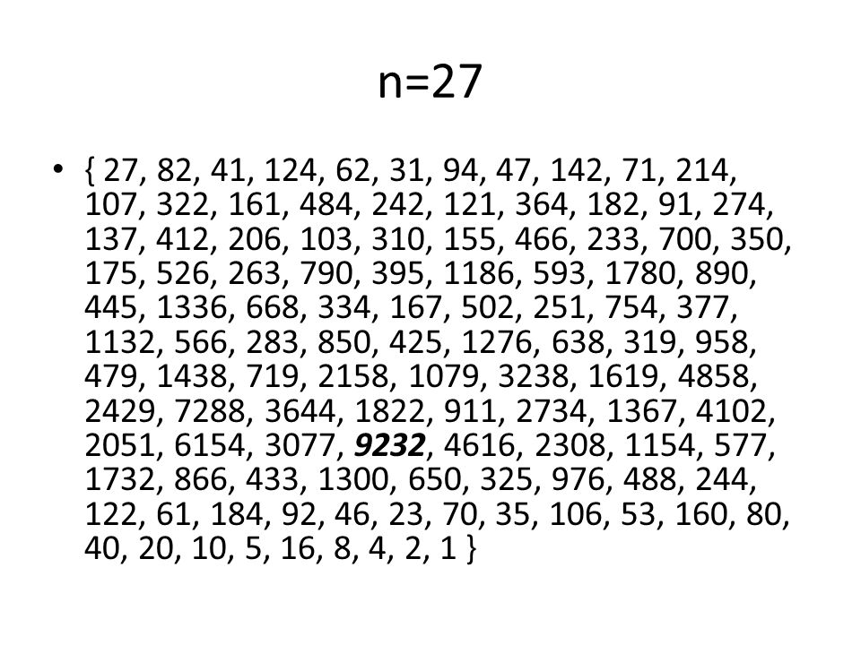

It takes 111 steps to get to 1, but it does get there eventually.

Write a program that will demonstrate this problem.

**Ask the user the number that starts the set.**

**Display the set and how many in the set.**